Navigate to <https://optimus.qa.callcreditdisputes.com/numerointeractive>

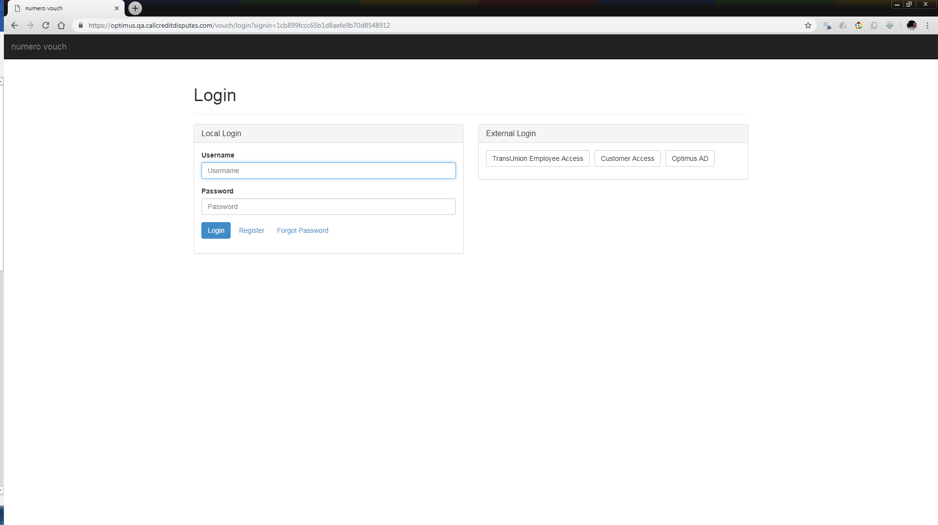

Click TransUnion Employee Access

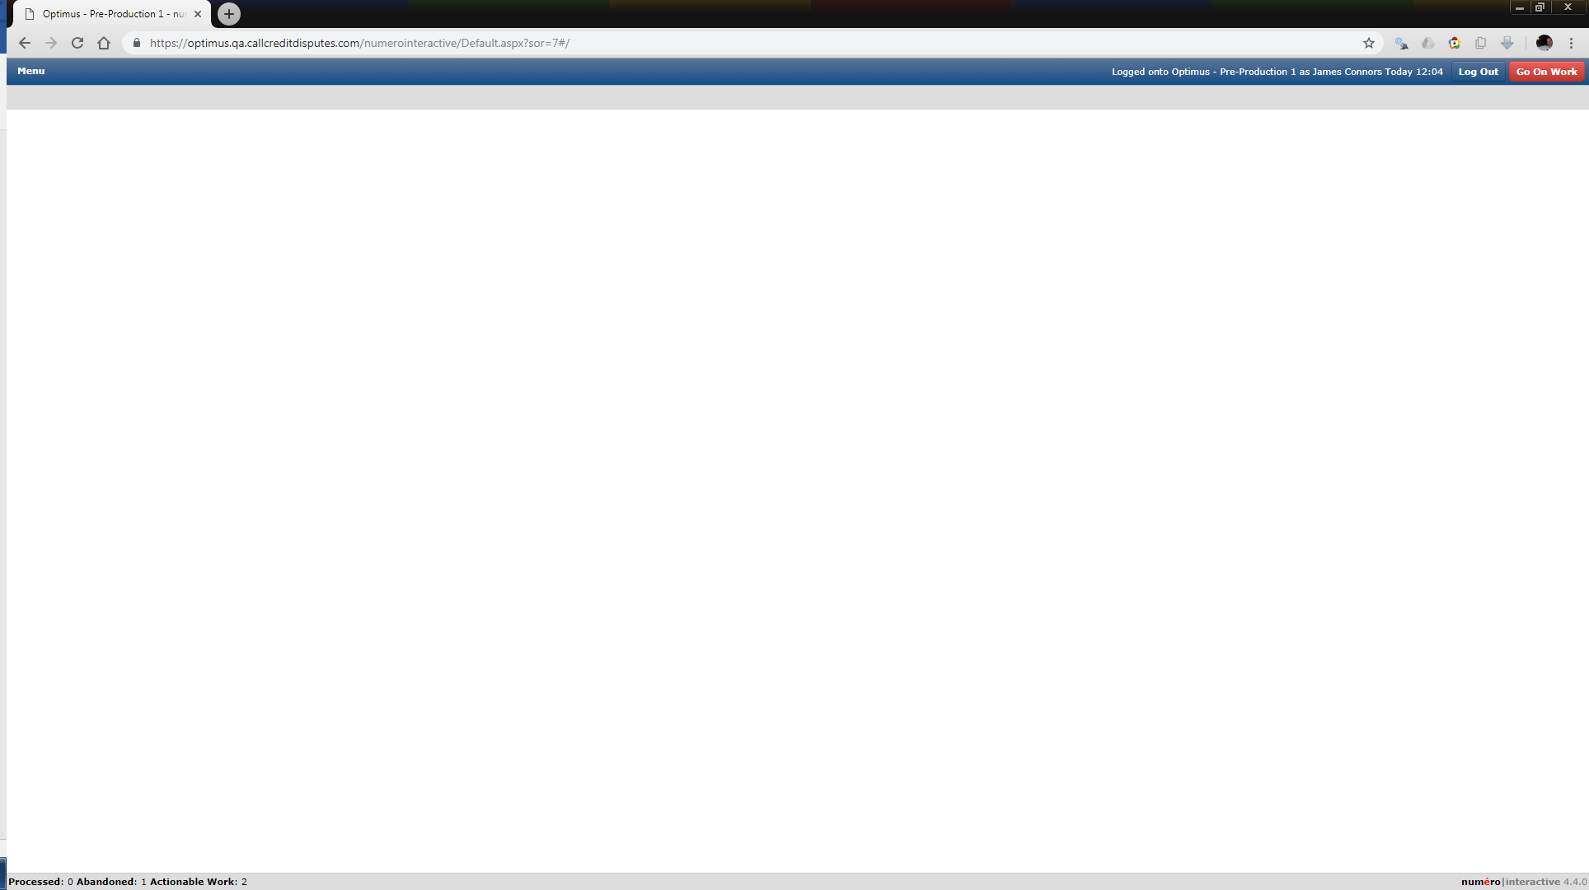

Navigate to Menu > Agent Console > Log Manual Dispute

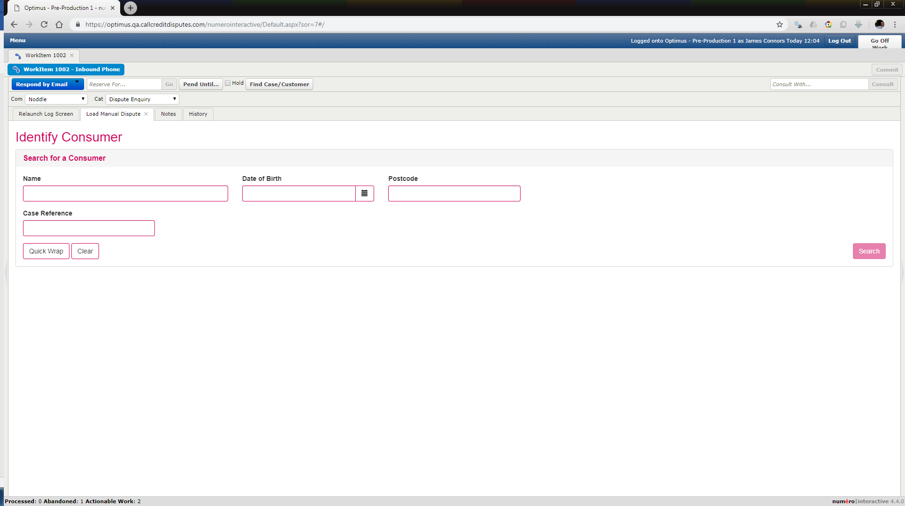

Enter search criteria

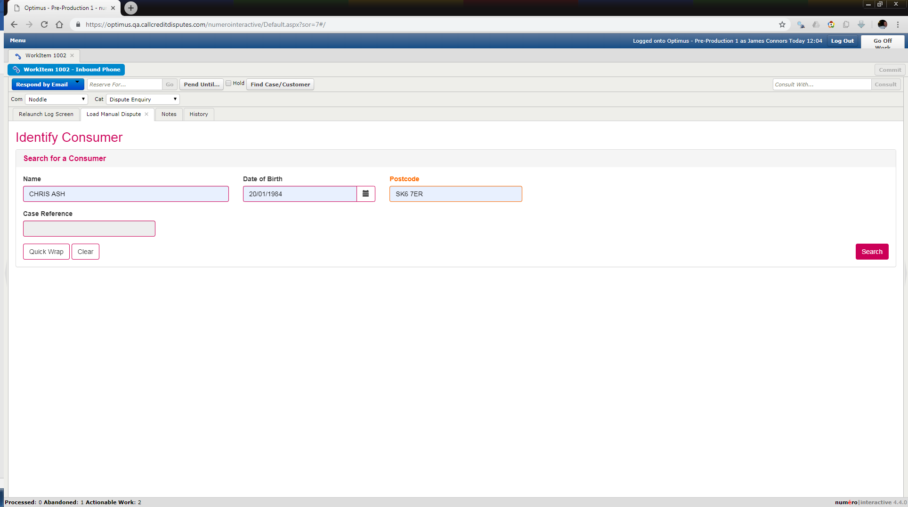

Click Search

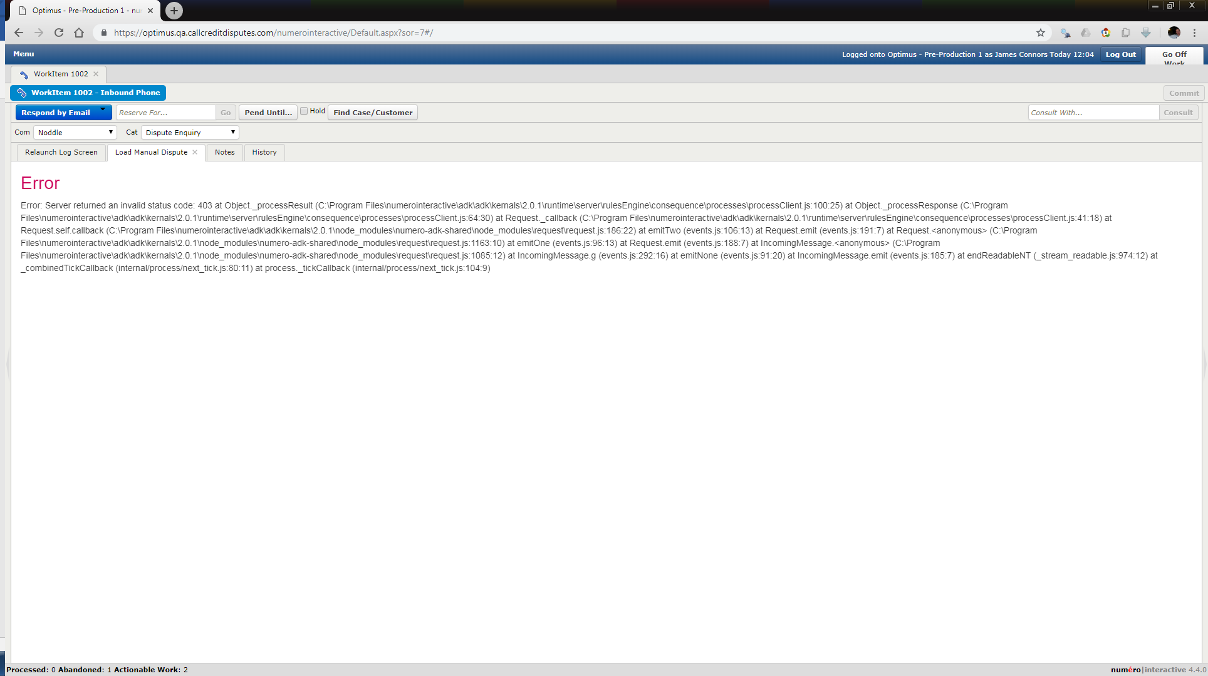

Text from the error;

Error

Error: Server returned an invalid status code: 403 at Object._processResult (C:\Program Files\numerointeractive\adk\adk\kernals\2.0.1\runtime\server\rulesEngine\consequence\processes\processClient.js:100:25) at Object._processResponse (C:\Program Files\numerointeractive\adk\adk\kernals\2.0.1\runtime\server\rulesEngine\consequence\processes\processClient.js:64:30) at Request._callback (C:\Program Files\numerointeractive\adk\adk\kernals\2.0.1\runtime\server\rulesEngine\consequence\processes\processClient.js:41:18) at Request.self.callback (C:\Program Files\numerointeractive\adk\adk\kernals\2.0.1\node_modules\numero-adk-shared\node_modules\request\request.js:186:22) at emitTwo (events.js:106:13) at Request.emit (events.js:191:7) at Request.<anonymous> (C:\Program Files\numerointeractive\adk\adk\kernals\2.0.1\node_modules\numero-adk-shared\node_modules\request\request.js:1163:10) at emitOne (events.js:96:13) at Request.emit (events.js:188:7) at IncomingMessage.<anonymous> (C:\Program Files\numerointeractive\adk\adk\kernals\2.0.1\node_modules\numero-adk-shared\node_modules\request\request.js:1085:12) at IncomingMessage.g (events.js:292:16) at emitNone (events.js:91:20) at IncomingMessage.emit (events.js:185:7) at endReadableNT (_stream_readable.js:974:12) at _combinedTickCallback (internal/process/next_tick.js:80:11) at process._tickCallback (internal/process/next_tick.js:104:9)